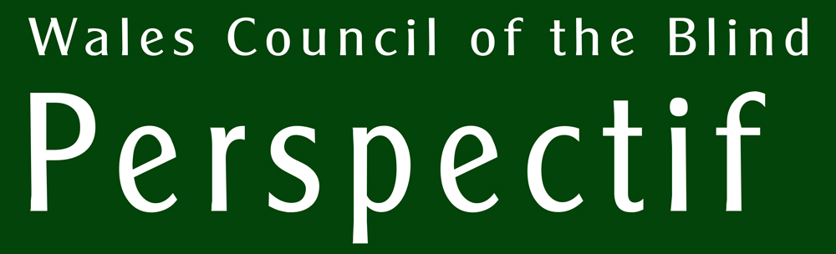 |  May 2026
Helping you to help your low vision patients

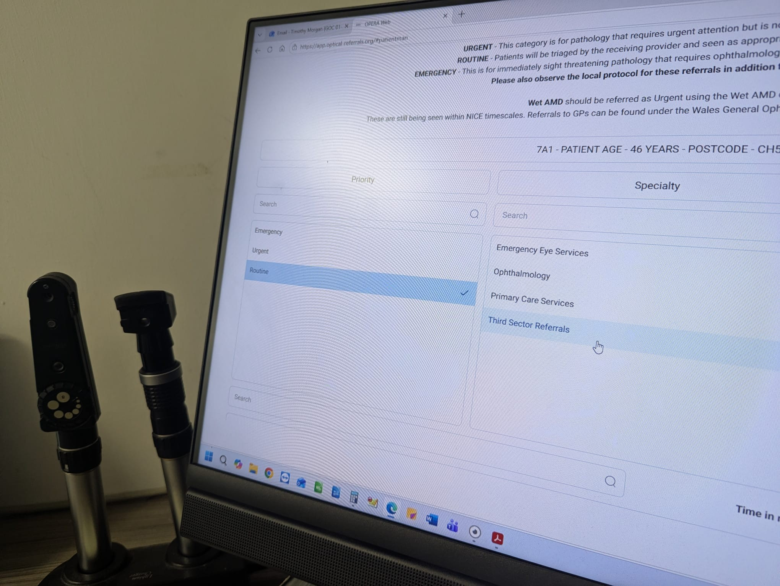
WALES VISION FORUM SUPPORT SERVICE AND THE ELECTRONIC REFERRAL SYSTEM

How the optometrists' referral interface can be used for signposting to non-medical support

Also in this edition ...

OPPORTUNITY FOR PATIENTS WITH DIABETIC MACULAR OEDEMA
Market research company seeks patients for interview

A CALLOUT FOR WELSH VOICES!
An opportunity for glaucoma patients to shape the future of glaucoma care

HIDDEN CARERS
A new report is published

SOCIAL ISOLATION AND LONELINESS
Research into the awareness amongst optometrists of these risks amongst their patients

LAUNCH OF SIGHT LOSS COUNCIL CYMRU
Report from the launch event at the Pierhead Building in Cardiff

THE WALES VISION FORUM WEBSITE
A resource aimed at people with sight loss and the people who support them

Opportunity for patients with Diabetic Macular Oedema to contribute to a market research study
Evolve Fieldwork is inviting patients who have been diagnosed with Diabetic Macular Oedema (DMO) to contribute to a market research study.
The company is interested in learning about personal experiences in relation to the condition, from when the patient first experienced symptoms through to today, including experiences of treatment and the healthcare teams involved in the patient's care. The research will take the form of a virtual 60-minute in-depth interview with a moderator. There will be £80 remuneration to the patient as a thank-you for their valuable time and contributions.
Research adheres to the market research codes of ethics and conduct of ESOMAR, the BHBIA, the ABPI, the Market Research Society and EphMRA, as well as the Data Protection Act of the UK and European laws protecting personal data, including the GDPR.
If you know of a patient who might be interested in contributing, please encourage them to complete this screening questionnaire to enable the company to contact them if they might be eligible. The link is https://forms.office.com/e/K4TzN5d4bJ .
A Callout for Welsh Voices!
The Glaucoma UK National Patient Voices Survey: an opportunity to shape the future of glaucoma care.
From July to August 2026, Glaucoma UK will launch the UK’s largest ever national survey of people affected by glaucoma, aiming to hear from around 10,000 people living with glaucoma or under regular monitoring.
The survey focuses on the lived experience of glaucoma. It looks beyond clinical outcomes to explore areas such as:
- understanding and communication
- anxiety about sight loss and uncertainty
- mental health and daily impact
- independence, driving and quality of life
Importantly, this is not an assessment or scoring of individual services or practices. The survey is designed to build a national picture of how glaucoma is experienced across the pathway, and to turn that insight into robust, credible evidence that can inform service design, research priorities and policy discussions at a national level.
How you can support the survey
You can inform patients with glaucoma of this opportunity. Support could be as simple as:
- briefly mentioning the survey during glaucoma-related appointments;
- displaying a poster to refer glaucoma patients to;
- sharing a short message via patient communications or websites;
- inviting Becky Burn (r.burn@glaucoma.uk) from Glaucoma UK to online or in-person events.
All materials are designed to be clear, accessible and easy to use, and we’re happy to work with you to find an approach that fits your setting.
Be part of what comes next
The insights from the National Patient Voices Survey will be used constructively, working with partners across the glaucoma pathway to advocate for change where it’s needed most.
By supporting this work, you are helping to ensure that future decisions about glaucoma care are grounded in the realities your patients live with every day.
To find out more about Glaucoma UK, access professional resources, or explore how you can get involved in the National Patient Voices Survey, visit www.glaucoma.uk/national-patient-voices-survey

Wales Vision Forum Support Service.
We are offering a third sector signposting service for optometry patients in Wales, using an Electronic Referral System (eRS). Optometrists will shortly be able to refer patients quickly to other areas of healthcare. Included within this system is the option to refer the patient into the Third Sector / charities via a dedicated signposting service run by Wales Council of the Blind on behalf of the Wales Vision Forum (WVF).
This service will generate referrals from the harder-to-reach patients who are often in the early stages of a sight condition.
This is a sector-wide service which is why the WVF is the ideal agency to carry out this part of the referral system, being composed of a range of stakeholder organisations throughout Wales and within the UK.
This referral will be made using a simple check box in the online optometry-based referral forms, directly emailing contact details and supporting information to an assigned email address. Upon receipt of the referral, WCB staff will use the WVF website and Perspectif (WCB's online database) to signpost / refer people to a range of support and services.
We will ensure that local, regional and national societies will be referred into (with permission from the patient) dependent on where they live. This will go some way to ensuring patients are given local third sector support, as well as that from the national providers.
Thanks to the eRS, our officers will be able to introduce patients to a range of support at an early stage, as well as potentially catching anyone with more significant sight loss who has slipped through the net.
We will develop, with WVF members, a script that would enable patients to be referred to a range of support services in the following categories:
- Befriending
- Clubs and social groups
- Counselling and emotional support
- Digital inclusion support
- Direct Payments
- Eye Clinic Liaison Officers
- Helplines
- Rehabilitation
- Resource centre
- Support groups
- Low Vision Service practitioners
- Welfare Benefits advice
We see this as a great opportunity to increase the support to patients from third sector organisations.
Records will be kept by WCB for as long as necessary (in accordance with GDPR) and anonymised data will be shared frequently with WVF members in order to measure the impact of the service.
Effective referral pathways
So that there is a consistent service across Wales, an effective model is a simple checkbox referral from the optometrist's Electronic Referral System. This places a minimum of additional work on the optometrist.
If the optometrist feels that the patient would benefit from support in the third sector, a question is put to the patient which obtains their consent for data to be shared with the Wales Vision Forum Support Service. Subsequently, upon receipt of an emailed referral, the patient will be contacted by WCB staff, most likely by telephone, for a conversation to determine the type and level of support they would benefit from; asked for consent to share their contact details if a referral is to be made; and given a choice of how they wish to receive information:
- Information over the telephone – this will most likely include telephone numbers of support services;
- Forward contact (with permission) directly to the service provider so that they can contact the patient directly;
- Sent a Perspectif package of links and phone numbers via email or text, or a print-out in their preferred format by post.
The questions to be asked of the patient can be answered by ticking a checkbox. After including the standard contact details, they are:
- Purpose of referral.
- Patient would like more information about their eye condition
- Patient would like information to help them prepare for their hospital eye appointment
- Patient's vision causes them difficulties carrying out everyday tasks such as cooking, driving, getting around, working, studying, managing their money
- Patient would like support on how best to take their eye drops
A free text field is provided for other information that will help WCB staff identify useful services for the patient. This might include some lifestyle information and detail about their circumstances that would enable a better understanding of the support they need.
The system has gone live in Betsi Cadwaldr and will soon be rolled out in other health boards in Wales.
More information about the Wales Vision Forum Support Service can be obtained from Wales Council of the Blind on 029 20 473 954.
Report of Study of Carers for People with Vision Impairment
Dr. Vanessa Webb was formerly the Director of Wales Council of the Blind from 1991 to 2008. She left to pursue an academic career and specialised in the subject of carers. Her PHD was on young carers and she sits on the Ministerial Advisory Group on unpaid carers and the Task-and-Finish Group looking at local authorities and the service they deliver for unpaid carers. She also sits on the Welsh Government appointed panel looking at the feasibility of a National Care Service free at the point of use.
At WCB we felt that the concept of 'carer' was more associated with paid carers in the broader disability and older people domains than in the sight loss sector, where it takes place rather informally and without the kinds of support offered to self-identified carers. We felt that Vanessa would be ideally placed to conduct some research into the situation of these 'hidden carers'.
Dr. Webb aimed to examine unpaid carers for people with vision impairment, to discover whether this form of caring differs in meaningful ways from others, and to explore how carers promote the independence of those they support. The study looks at how the lived complexity of relationships sits with policy-led categorisation of carers.
Although the sample is small — the report is frank about this — the interviews are densely populated with voices, habits, worries, workarounds, irritations and moments of humour. As a result, people recur in the text not as anonymised datapoints but as characters one begins to recognise: Oliver with his spreadsheets and technology, Penny baking again under LED lights, Leo photographing the world to see it more clearly, Bill sky-diving at eighty. This accumulation of detail does more than illustrate findings; it quietly undermines any simplistic account of dependence. Sight loss here is not a single event but a shifting condition, and caring is not a stable role but a constantly adjusted practice.
This focus on instability — of vision, of circumstances, of roles — is one of the report’s most significant contributions. The research plan acknowledges at the outset that sight conditions change over time, and the interviews reveal this. Not only does vision fluctuate biologically, it affects domestic life, leisure, work, and social engagement in ways that add to the instability. The consequence for carers is not simply workload, but vigilance: an unceasing attentiveness to risk, to environment, to the possibility that what worked yesterday may not work tomorrow. The report returns to this idea repeatedly. Caring for a v.i. person emerges not as constant physical labour, nor even emotional labour in the conventional sense, but as a form of being “on the alert”, planning ahead, foreseeing problems before they materialise.
What carers describe is not exhaustion alone, but a particular kind of stress produced by anticipation rather than action. It is telling that respite sometimes fits uncomfortably here. Many of the people with sight loss are otherwise fully capable adults, often active, opinionated, socially engaged, sometimes stubbornly independent. To frame them as passive recipients of care is not only inaccurate but actively disruptive to relationships that function as partnerships. The report’s recurring discomfort with the term “carer” is thus well placed, and points to an initial misconception on our part. In many of these accounts, caring is reciprocal and sometimes almost incidental — “I’m your wife and I just do it”.
The report offers surprises that are disarming insofar as they disrupt one's preconceptions. One carer’s remark — “I want him to be independent because it takes pressure off me” — is frank and cuts through any assumption of selflessness. The study’s central conclusion — that the best way to support carers is to promote the independence of the v.i. person — is evident in such simple statements. There is no attempt to romanticise the nature of the relationship.
One takeaway from the report is that interviewees are grateful for what they receive, often effusive in their praise, but frequently unable to name roles, organisations or points of access. Help arrives, but as if by chance. The system appears not as a pathway but as a chance set of encounters. This points to a frequently raised need in our sector generally for coordinated signposting that doesn't leave people exposed to the vagaries of service provision.
The low take-up of carers’ assessments and formal support for carers themselves features in the report. Many carers do not seek assessments, others are unsure whether they have had one, some find them intrusive or irrelevant. This suggests a mismatch between policy and the reality of people's lives. The report suggests joint assessments might be more appropriate, presumably because the relationship is more of a partnership than might be found in other caring situations.
While recognising that there is bereavement, frustration, anxiety, and moments of depression, there is also adaptation, ingenuity, persistence, even recklessness. People train their own guide dogs during Covid delays; they redesign task lighting; they master digital tools late in life; they volunteer, organise, chair committees, race cars. The report does not sentimentalise this, but it does insist on recognising it and thereby avoids the trap of mistaking vulnerability for diminishment.
Experiences of public attitudes are notable in how much of the burden of managing these interactions falls not only on the v.i. person but on the carer, who takes on a mediation role. This is central to understanding the lived reality of caring in this context.
In addition to its recommendations, the report builds a picture of caring as a nuanced, time-varying practice. However, it also reiterates common notions that the most effective supports are often simple: better lighting, accessible information, reliable technology support, clarity about communication preferences. These familiar interventions do not necessarily form “carer support”, yet they do a great deal to increase independence.
We are so grateful to Dr Webb for producing this report for us. The report is available in the WCB Perspectif website library at carers-for-people-with-vision-impairment
How do eye care practitioners approach social isolation and loneliness in people with vision impairment accessing the Low Vision Service Wales?
WCB commissioned Rebecca John to conduct research into the extent to which Low Vision Service optometrists conducting conversations with patients about lifestyle and non-medical support needs are identifying and addressing the risks of loneliness and social isolation. The study, funded by Fight For Sight, looks at how practitioners think about, identify, and respond to social isolation and loneliness among people with vision impairment. These issues are well known to be harmful to health and wellbeing, and people with sight loss are especially at risk. This research was modelled on similar research(1) that evaluated the implementation of Whooley questions to enable WGOS3 low vision practitioners to identify depression. Those questions are ﻿1) during the past month, have you often been bothered by feeling down, depressed or hopeless? and 2) during the past month, have you often been bothered by little interest or pleasure in doing things? What this present research explores is practioners' knowledge of patients' loneliness and social isolation and – if they know loneliness matters – what actions are taken in practice?
The answer is mixed, and that is precisely what makes the study useful, because we are seeking ways to facilitate better signposting, perhaps using a similar trigger question method akin to the Whooley questions.
Practitioners clearly understand the problem. Almost all those surveyed recognise that loneliness and social isolation are common for people with vision impairment and that these experiences can seriously affect mental and physical health. In interviews, practitioners show a thoughtful grasp of the difference between being socially isolated (having few contacts) and feeling lonely (feeling disconnected even when others are present). They often avoid clinical language and talk instead about how people describe their own lives and feelings.
The WGOS3 Low Vision Service has a strong lifelstyle and emotional component in the conversations conducted with patients. Practitioners report generally feeling confident talking to patients about how they are feeling, listening for clues, and picking up on unease, frustration or withdrawal. Low vision appointments tend to be longer and more personal than many clinical encounters, and this gives space for these issues to surface naturally within the conversation. In that sense, the study shows WGOS3 practitioners to be well placed to notice loneliness.
What happens after loneliness is identified is less consistent. Very few practitioners use formal screening tools, and actions beyond the conversation vary widely. Some refer patients to third‑sector organisations or community support, but many do this only some of the time. Confidence drops sharply when practitioners have to involve family members, contact GPs, or guide patients towards specific services. As one practitioner neatly puts it: “We can spot it, but what do we do next?”
A recurring theme is the lack of clear pathways. Practitioners describe uncertainty about where to refer people, what support exists locally, and how reliable or accessible that support might be. Digital resources such as the Perspectif portal are seen as promising but training is needed in its use. As a result, much depends on practitioners’ personal knowledge rather than sharing and using a common system.
The study also reveals subtler issues. Patients may be reluctant to admit loneliness out of pride or fear of being a burden. The presence of family members can make disclosure harder rather than easier, especially when patients don’t want to appear ungrateful. Living with others is shown to be no guarantee against loneliness – a reminder that it is the quality of connection, not its quantity, that matters. This reluctance on the part of the patient is an argument for a tool similar to the Whooley questions so that practitioner is able discreetly to make an evaluation of the need for support.
One of the most striking findings is how loneliness affects the use of aids and equipment. Practitioners describe people who disengage from low‑vision aids and strategies when they feel unsupported, even when the equipment works well. In contrast, those with emotional and social support are more likely to persist. This makes loneliness not just a social issue, but a practical barrier to independence.
Overall, the study paints a picture of a service with strong human instincts but limited structural support. Practitioners care, notice, and listen — but they lack consistent tools, guidance and pathways to act confidently and systematically. Dr. Rebecca John suggests that routine screening questions, clearer referral routes, and better‑designed information resources will be a way forward. Rather than adding to workload, these changes would help practitioners do what they already value: seeing the whole person, not just their eyesight. The study makes an important point — addressing loneliness is not an “extra”, but part of enabling people with vision impairment to live, cope, and remain connected.
The report will shortly be available in the WCB Perspectif library online.

The Wales Vision Forum page on Social Isolation and Loneliness is at https://walesvisionforum.org.uk/loneliness-social-isolation

(1) Nollett CL, Bray N, Bunce C, et al. Depression in Visual Impairment Trial (DEPVIT): A Randomized Clinical Trial of Depression Treatments in People With Low Vision. Investigative Ophthalmology & Visual Science. Aug 2016;57(10):4247-4254. doi:10.1167/iovs.16-19345

Launch of Sight Loss Council Cymru

The launch of Sight Loss Council Cymru (SLC Cymru) was a positive and inspiring event, held during Welsh Charities Week, and marked an important milestone for blind and partially sighted people across Wales.

A strong note of thanks was given to Jenny Rathbone MS, whose sponsorship enabled the launch. Attendees were also welcomed from across the sight loss sector, creating a sense of shared purpose from the very beginning.

The event opened with a warm welcome from Owen Williams, Director of WCB, who introduced the audience to the work of Wales Council of the Blind (WCB). He mentioned WCB’s role as a representative body for blind and partially sighted people, alongside its commitment to collaboration and lived‑experience leadership.

The heart of the event was the formal launch of Sight Loss Council Cymru, a two‑year pilot project run by WCB and funded by Thomas Pocklington Trust. The Council brings together 19 volunteer representatives, all of whom are blind or partially sighted, with representation from every Health Board region in Wales. This ensured that the Council is firmly rooted in diverse lived experiences from across Wales.

Attendees learned how SLC Cymru will work closely with Local Action Groups and local sight loss organisations, helping to make sure that the voices of blind and partially sighted people directly inform decision‑making at both local and national levels. Exciting developments were shared around new and existing Local Action Groups, including work in Cwm Taf Morgannwg, Betsi Cadwalader, and West Wales.

The relationship between SLC Cymru and the Wales Vision Forum was also highlighted, showing how the new Council will help strengthen collaboration across the sight loss sector and support coordinated national campaigning.

The event featured contributions from Martin Symcox, Head of Partnerships and Projects at Thomas Pocklington Trust, and Anita Davies, Engagement Manager for SLC Cymru, who introduced the Council representatives and shared the vision for the project.

The launch included an address from Jane Hutt MS, Cabinet Secretary for Social Justice. Jane was warmly thanked for her longstanding commitment to disabled people in Wales, including her leadership on the 10‑year Disabled People’s Rights Plan (2025–2035). Her formal launch of SLC Cymru was a fitting and memorable highlight.

For more information about Sight Loss Council Cymru and the Local Action Groups, please contact Anita Davies, SLC Cymru Engagement Manager via anita@wcb-ccd.org.uk or 029 20 473954. A web page is at wcb-ccd.org.uk/slc-cymru

Wales Vision Forum: A Practical Guide to Eye Health and Sight Loss Support in Wales

The Wales Vision Forum website is a valuable, easy-to-use online resource designed to help people in Wales understand eye health, navigate sight loss, and find appropriate support, wherever they are in their life as a blind partially sighted person.

Developed collaboratively by local, regional, and national organisations representing people with sight loss, the site acts as a central signposting hub. Rather than replacing clinical advice or referral pathways, it brings together clear, trustworthy information in one place, helping individuals, families, and professionals know where to go next.

What the website offers
The website is organised around the eye care and sight loss journey, from noticing early concerns through to living well with long-term sight impairment. Key sections include:

- Eye health and early action, encouraging regular eye tests and explaining what to do if vision changes suddenly;
- Understanding diagnosis, with plain‑language explanations to help people make sense of eye conditions;
- Support after diagnosis, including emotional, practical, and social help;
- Living well, covering wellbeing, staying active, and maintaining independence.

A significant strength of the site is its clear explanation of Welsh General Ophthalmic Services (WGOS). It outlines what services exist in Wales – such as routine eye examinations, urgent eye care, low vision assessments, and independent prescribing – so users better understand what support is available locally and free at the point of access where applicable.

Why it’s useful
For people experiencing sight problems, the website reduces uncertainty at what can be a stressful time. For families, carers, and professionals, it provides a shared reference point that supports consistent messages and informed conversations.

The site also signposts to wider support, including help for children and young people, information about loneliness and social isolation, and links to voluntary and community organisations across Wales.

Working together
Behind the website is the Wales Vision Forum itself – a partnership focused on improving collaboration, reducing duplication, and maximising the collective impact of sight loss organisations in Wales.

In short, walesvisionforum.org.uk is a practical, accessible gateway to eye care information and sight loss support in Wales, empowering people to take informed steps and connect with the right help at the right time.

Pathways in Practice: Supporting People with Sight Loss Across Wales

Join Wales Council of the Blind and partners for a series of practical, interactive events across Wales, bringing together eye care, health, social care and third sector professionals to strengthen local referral pathways and improve support for people living with sight loss.

Learn about signposting through the electronic referral system; what the third sector can offer your patients; what a vision rehabilitation specialist does; support for children with sight loss; and the role of the Eye Clinic Liaison Officer.
You’ll leave with clearer connections, better signposting options, and a shared understanding of who does what - so people can access the right support at the right time.

Who should attend? Optometrists and Dispensing Opticians, Vision Rehabilitation, ECLOs, Third Sector organisations, Managing Better workers, and Qualified Teachers of the Vision Impaired.

- 2 interactive CPD points available for Optometrists and Dispensing Opticians

Times: Registration from 5.30 pm – food and refreshments served from 6.00 pm – presentations and group discussions will run from 6.30 pm – 8.45 pm.

Book your place: Spaces may be limited - please reserve your place below:

Cardiff & Vale: https://pathwaysinpracticeCardiff.eventbrite.co.uk
Tuesday, 2nd June, Holland House Hotel CardiffBySunday, Cardiff

Cwm Taf Morgannwg: https://pathwaysinpracticeCwmtaf.eventbrite.co.uk
9th June, Heritage Park Hotel, Pontypridd

Aneurin Bevan: https://pathwaysinpracticeAneurinBevan.eventbrite.co.uk
11th June, Mercure Hotel, Newport

Powys: https://pathwaysinpracticePowys.eventbrite.co.uk
18th June, Metropole Hotel, Llandrindod Wells

Hywel Dda: https://pathwaysinpracticeHywelDda.eventbrite.co.uk
2nd July, Ivy Bush Royal Hotel, Carmarthen

Betsi Cadwaladr: https://pathwaysinpracticeBetsi.eventbrite.co.uk
7th July, The Kinmel Hotel, Abergele

Swansea Bay: https://pathwaysinpracticeSwansea.eventbrite.co.uk
14th July, Grand Hotel, Swansea

