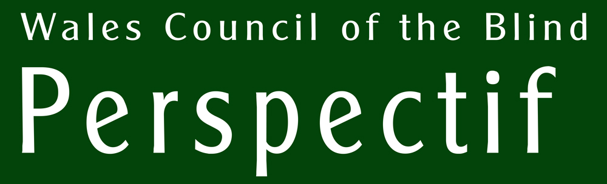

UPDATE - June 2023

Welcome on board! Low Vision Service Wales practitioners invited to sign up to Perspectif

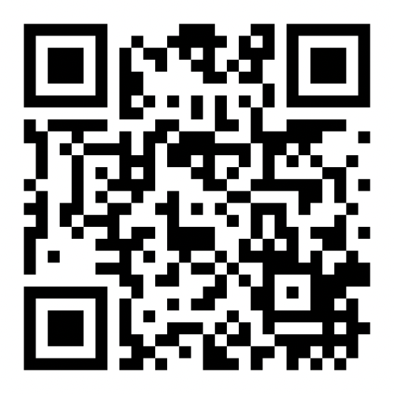
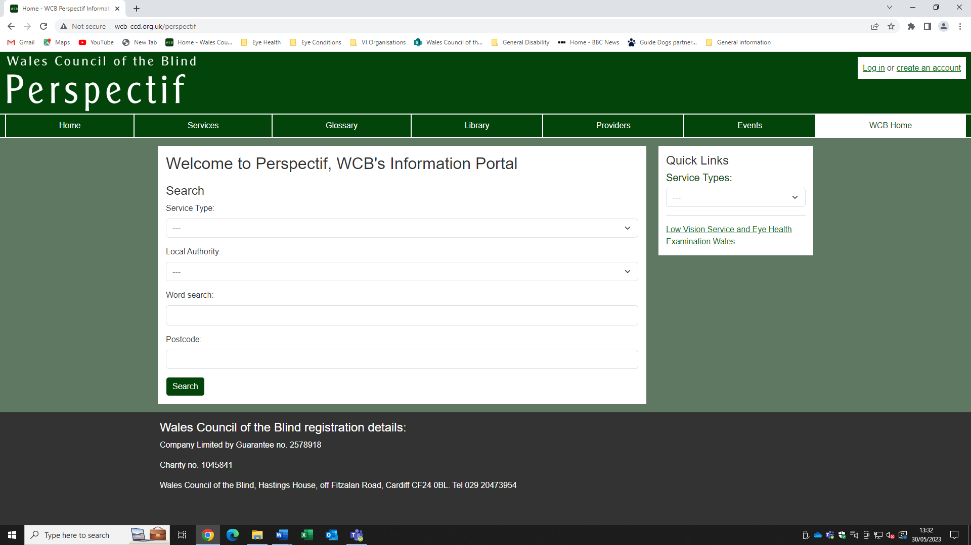
Scan this QR code to browse Perspectif
PERSPECTIF UPDATE

You are reading one of a number of Perspectif Updates. It is not the first - previous editions are available at our main website http://wcb-ccd.org.uk. But these shall become regular themed publications to show recent additions and changes to the portal along with featured services. They will keep you up-to-date with changes to the site, new entries in the database, and keep you aware of the portal as a useful part of LVSW assessments. As a signed up user of Perspective you can receive the bulletin in your preferred format: print, large print, email, audio.

Richard Bowers explains the background to Perspectif and how it currently works.
A short background. Back in the 1990s Wales Council of the Blind, like most organisations, kept a database of organisations who might be of use to people with sight loss and our member organisations. We used this internally and it was maintained patiently by our volunteer, Ann. However, with the growth of online services we decided to make this available to everyone and started planning a web-based version.

I implemented the early version and subsequently took on other developers until it became a bit unmanageable. Importantly, it was built with a version of software that was soon to become unsupported. Jack, our current developer, has completely overhauled it to make use of the latest software version and other new technologies. We are developing new features all the time. It’s at http://wcb-ccd.org.uk/perspectif

It has been the only online database in Wales to help people with sight loss and support workers find services to support them. It started out with a simple principle that people need help with specific things and they should be given as much choice as possible, finding things that are best suited to them. This meant that our focus is primarily on services, not the organisations that provide them.

Another principle is that we should keep a minimum of information and direct people to the sources of support where the providers are able to maintain their own information about the services.

Low Vision Service Wales has collaborated with us to embed this into the practitioners’ work streams, enabling a quick way to obtain customized information for their patients to take away. It is essentially a tool for social prescribing.

NEW DEVELOPMENTS

Features.

For those of you who know Perspectif already, here are some new features:

- searching by keyword from the home page
- an events calendar linked to service and provider records
- an option to create groups of specialist site users (eg LVSW practitioners).
- a postcode-based distance indicator
- a filtering facility for the events page
- a word search for the Library records

Wales Eye Care Services.

The Low Vision Service Wales and the Eye Health Examination Wales are services that are crucial for maintaining eye health for at risk people and for obtaining low vision aids for people with low visual acuity. Since the closing down of the WECS website, where public and support workers were able to locate the nearest WECS practitioner, Perspectif has included all EHEW and LVSW (including domiciliary) practitioners. These can now be searched by clicking on the link called ‘Low Vision Service and Eye Heath Examination Wales’. This link is available from most pages on the site. On the WECS page you have the opportunity to select which service(s) you want and add a postcode to rank them by distance.

The new CVI.

The Certificate of Vision Impairment or CVI will soon be completed by LVSW practitioners for their Bilateral Dry AMD patients. This is part of the Welsh Government’s plan to get more healthcare services delivered on the high street. WCB is listed within the Certificate of Vision Impairment (Wales) as the single point of access to information about services. This was a decision arrived at through agreement from the Wales Vision Forum. We believe that the sector is keen to have an impartial organization offering signposting services for patients in receipt of a CVI and we hope that people newly certified will now have access to further support through Perspectif.

WHAT IS PERSPECTIF?

SOME TERMS.

Perspectif is a database of Services that are delivered by Providers. There is also a Library that will be added to over time and an Events diary which is continually updated. A Glossary of terms is also included and this can also be used to find related services.

The thing to remember is that there are many routes through the information due to the dynamically-created links in different parts of the site. If, for example, you looked at the Glossary page for Budgets – personal, you would see beneath the definition a list of services that use that term and a Library item that uses it in its own record. Also, you might notice that Service descriptions have links on certain words: these take you to the definition for that term in the Glossary and reveals the other services that relate to that term. So, it’s easy to move around, gathering information as you go.

SERVICES

What do we mean by Services? Services is a very broad term for any activity or product that might be helpful to people with low vision. They range from social groups to benefits advisors, sports clubs to accessible technology resellers; and, of course, Wales Eye Care Services practitioners! Naturally, we are focusing on those that are designed for people with sight problems but not exclusively. It is natural that we must reach into the broader disability field, for example, and other health and social care fields such as mental health services.

Apart from a name and description, the service record might include a website, email address, coverage and postcode. Also, we can add keywords to help with searching. Every Service will be attached to a Provider.

PROVIDERS

Providers are the organisations, companies, groups, social enterprises, not-for-profit organisations and so on that provide services. In general, they are organisations such as your local society, the NHS, national sight loss charities, assistive technology companies and so on. No Services are listed which do not have a Provider.

EVENTS

We have an Events diary; each event can be clicked on for more information. Also, where events are provided by one of the service Providers listed in Perspectif, you’ll find them listed below the record for that provider. Similarly, the Services themselves, if they are event-based such as a coffee morning, will show the events beneath the Service record. Macular Society is a good example if you want to see how this works.

THE LIBRARY

The Perspectif Library shall become the central repository in Wales for information on sight loss and support. It shall include leaflets, reports, newsletters and the like and shall be stored on the WCB server. Naturally, the list of publications shall grow, so there is a word search to help you find things. We aim to make a deeper search engine that searches within the documents themselves. We aim to create a deeper search facility that will search through the documents themselves, not just our records.

We try to keep copies of the publications on our own server as far as possible. This is largely because they can be more reliably accessed there. In some cases, they will only be available on an external site.

GLOSSARY

The Glossary functions as a list of terms with definitions in the fields of disability, social care, eye health, welfare benefits and so on. It also functions as a focus for services and library records that relate to the terms it holds. So, for instance, the term ‘assessment’ will give a definition and beneath it, a list of services and library items mentioning that term.

SEARCHING

In the menu of Perspectif you can choose to browse through all Service records in the database (as well as other records: Providers, Library, Glossary, and Events). However, it’s not the best way to search for specific services. It’s better to use the Search tool for this.

The main page at http://wcb-ccd.org.uk/perspectif is where you can find a search section. Here, you’ll find these fields:

- Service Type
- Local Authority
- Word Search and
- Postcode.

Service types.

You can search by selecting a category first … We have tried to group services meaningfully into a small set of categories called Service Types. (There is also the same drop-down list on every page where you can select a category). These categories are a rough guide but offer a quick way to find results if you know what you are looking for. Every service in Perspectif is attached to one category, and one only.

Local Authority

You can select a local authority as a filter on your search. The local authority field chooses services that are available in that area. We call this ‘coverage’ and you can see the coverage for a service in its full record. Some services are UK-wide, all-Wales, or for one or more local authority areas. We try to distinguish between location and coverage. This is because some services will be at a fixed location but will support people from a number of local authorities in their area.
On the search results page the Services that match the criteria are shown first. ‘Other results’ may follow and might be Services that operate in a different geographical area. Obviously, in the absence of something closer to home, these other results might be useful.

Word search

This is new feature added to the search which is, as with the other fields, optional. However, it might help to identify something more specific. For example, you might choose Sports, Arts, Leisure and Holidays from the service type drop-down menu and find that there’s too much to sort through. You want to do walking, so you type that into the word search field as well and you get a more focused result. The word search can help to narrow down the results. But it relies on the word or words being present in the records, so sometimes you might need to try different words.

To use it, type a keyword and press ENTER. This will create a delete-able blob. A keyword can be made up from more than one word. You can also add a number of Keywords. Then hit the search button to get the results. The keyword you include in your search shall be checked against words in the service names and descriptions and, where they have been included, in a specific keyword field in the service record. Where this matches, and the other criteria have been met, the service shall be shown in the results.

Postcode

You can add a valid postcode here to find out how far - as the crow flies - the services are from, say, the client’s home address. (Remember: this postcode will not be saved to the database.) The postcode doesn’t act as a search filter; it simply enables the distance to be given for the services that are returned from your search, where relevant.

So…

Category, location, keyword, and postcode can be used singly or together in any combination. In other words, you don’t have to enter all the fields: you can, for instance, just choose Resource Centre from the Service Type drop-down menu and hit search. This will bring up all the resource centres listed. Alternatively, you might simply select Carmarthenshire in the Local Authority field and leave the Service Type empty. This will bring up all services that are available in Bridgend. As you’d expect, choosing Resource Centre AND Carmarthenshire will bring up the centre that covers that area. It’s worth spending some time trying out different combinations to see how they affect the results.

(Note that the search currently only works on Services – it does not search through Providers or other types of information in Perspectif. This is to keep the focus on Services, as we believe that the patient is primarily interested in getting a range of options from different Providers.)
Search results.

The search results appear on a new page. You are presented with the names and descriptions of each service along with the distance from a submitted postcode (where the service has a fixed postcode). Click on the service name or ‘More information’ to see the full record. Here you will see who provides the service, some contact details, a website, the full geographical coverage and so on. Again, if you follow the Provider link, you’ll be taken to the full record for the organisation along with the other services, events and library items associated with their name.

REGISTERING AS A USER

There is one clear benefit to signing up. Once logged in, you are able to create any number of Folders, rather like shopping baskets in an online store, where you can store any service, service provider, glossary term, event, or library item. Another benefit is that we at WCB can understand where there is a need to ‘tweak’ the database where there seem to be problems. For instance, we might find that LVSW practitioners are making a lot of referrals to a befriending group in one area, but not elsewhere. By examining the data we might find that there is a problem with the service appearing in searches, so we can fix that so that patients are signposted to this otherwise popular service.

You can log in, or create an account, from the menu bar at the top. You’ll be asked for your username and password. If you have any difficulties logging in there’ll be an email address and a phone number to get help.

You create a folder under the section ‘Your folders’ by typing any name and clicking ‘create folder’. This will automatically open the folder so that you can start adding items. You’ll notice that all items in Perspectif now have buttons to add (or remove) them to (or from) your open Folder.

(Please note that no patient data is stored on our database. However, we recommend that you anonymise the patients’ names if you wish to create Folders for specific patients).

Once you have added items to the Folder, you can view its entire content. Click the ‘view full content’ button in the ‘Your folders’ section. Now you have the full records for each item on a single page. You can also click ‘print view’ in the top right corner of the full content page to get a plain text version of the folder. Print view is useful if you wanted to cut and paste the folder into an email to send to the patient or perhaps into Word to make a large print version. You could even use it to produce a version in Braille.

Note that the contents of the folder will be updated when the records are changed in Perspectif. So, each time you go back to a folder, the information would be up-to-date (except when you create your own Word version, of course). This is really useful for follow-up assessments: you can have a conversation with your patient about the services you recommended at the previous appointment.

If you close a folder using the Close Folder button, you shall be able to access the Manage Folders section. Here it is currently possible to rename, delete, and duplicate folders. We recommend that you create a new (anonymised) folder for each patient, rather than duplicating the same folder. This is to ensure that the patient is given a person-centred service and that as a practitioner, you are maintaining awareness of what is available to patients on a regular basis.

About Wales Council of the Blind

Founded in 1938, Wales Council of the Blind is the only independent umbrella agency for vision impairment in Wales representing blind and partially sighted people and the clubs and societies who support them. Our independence enables us to act as an impartial observer, advocate, intermediary and evaluator for this complex, diverse group of organisations and services.

We gather the opinions and views of people with sight loss through groups and consultation. We put their voice at the centre of what we do, reporting on their views to the people who are responsible for the services that help them. We also act as an agency to direct people to these services, giving them impartial advice and choice.

Wales Council of the Blind
3.1 Hastings House, Fitzalan Place, Cardiff CF24 0BL
Tel: 02920 473 954
Email: richard@wcb-ccd.org.uk
Website: www.wcb-ccd.org.uk

